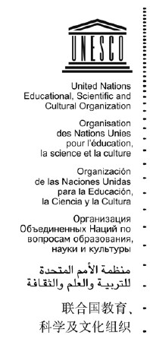

**Internal Oversight Service**

**Audit Section**

**IOS/2022**

**Original: English**

**Initial Risk Assessment**

**Audit of UNESCO’s Multi-Sectoral**

**Regional Office in Yaoundé**

*March 2022*

**Audit team:**

Helen Thanassoulias

Christian Muco

|  |
| --- |
| **BACKGROUND** |

**Office Role[1]**

As part of the Organization's overall strategy and in accordance with the decisions of its governing bodies, the Multisectoral Regional Office for Central Africa has the mission of ensuring the implementation of regional strategic orientations while meeting the needs specific to the countries in the various fields of competence of UNESCO. The new architecture of the field network in Africa also intends to promote synergies with the regional economic communities.

The mandate of the UNESCO Office in Yaoundé ensures coverage of the following countries: Angola, Burundi, Cameroon, Congo, Gabon, Equatorial Guinea, Central African Republic, Democratic Republic of Congo, Sao Tome and Principe and Chad.

**Context of the region**

Demographics

**Donors’ landscape**

**UN AGENCIES IN CAMEROON**

**UNDSS data**

How many agencies? Size of these? UNESCO’s size in comparison…

<https://cameroon.un.org/fr/about/un-entities-in-country> 20 UN Agencies

FAO, IFAD, ILO, IOM, ITU, OCHA, OHCHR, UN ECA, UN Women, UNAIDS, UNDP, UNESCO, UNFPA, UNHCR, UNIC, UNICEF, UNIDO, UNV, WFP and WHO.

**OFFICE STRATEGY, STRUCTURE AND PORTFOLIO**

**UCS**

The latest UCS on PAX website is (2008-2009)

There is a draft UCS 2020-2024 for Angola, Burundi, Cameroon, Congo Brazzaville, DRC, Equatorial Guinnée, Sao Tome et Principe. However, its been a couple of years since there was a formal UCS or UNDAF. The last UNDAF for Cameroon below ended in 2020.

**UNDAF**



The latest UNDAF covers the period 2018-2020. It was founded on four pillars and UNESCO is expected to intervene in two Pillars namely:

* Pillar 1: Development of decent job opportunities and social inclusion
* Pillar 3. Education and Vocational Training

**Office portfolio**

The office has a significant portfolio of Voluntary Contributions projects that were being implemented in the time scope of the audit. Between 2019 and January 2022, there were 55 VC budget codes being implemented directly by the regional Office. In addition, the office was allocated activities for implementation from 19 decentralized funds in the categories of GLO, FOE, MAS, RAF and INT. This Audit will review a sample of 21 VC Projects listed in table 1 below.

**Table 1 – Sample VC Projects for Review**

|  |  |  |  |
| --- | --- | --- | --- |
| **Budget code** | **Project title (short)** | **Donor** | **Total Allocation** |
| 727CHD1005 | Projet de Renforcement de l'Education et de l'Alphabétisation au Tchad (PREAT) | GPE/World Bank | $16,460,912 |
| 927CMR5001 | Appui au développement local à travers les médias communautaires, phase 2 | CAMEROON | $11,099,143 |
| 727CMR1000 | PROJET GPE DE RIPOSTE D'URGENCE CONTRE LA COVID-19 DANS L'ENSEIGNEMENT DE BASE AU CAMEROUN | GPE/World Bank | $11,000,000 |
| 467GLO1013 | CapED Programme - Improving Quality thro | Multidonor | 10,720,843.67 |
| 727CHD1007 | Projet d'Urgence de Renforcement de l'Education et de l'Alphabétisation au Tchad (PUREAT) | GPE/World Bank | $10,000,000 |
| 947EQG1001 | Projet d’appui à la mise en service et au développement de l’Université Afro-Américaine d’Afrique Centrale (AAUCA) en Guinée équatoriale - 2nd phase | Equatorial Guinea | $6,923,863 |
| 927CMR5000 | APPUI AU DEVELOPPEMENT LOCAL A TRAVERS LES RADIOS COMMUNAUTAIRES | CAMEROON | $5,838,424 |
| 549RAF4001 | Central Africa World Heritage Forest Ini | EU | 5,678,083.00 |
| 235CMR3002 | Les Jeunes tisserands de la paix dans les régions transfrontalières du Gabon, Cameroun et Tchad - Volet Cameroun (MPTF ID # 00124134) | UN-Peacebuilding Fund | $1,093,398 |
| CAM0120045 | Scaling-Up Rural Households' Use of Rene | UNDP | $970,874 |
| 235CMR3001 | Appui à la participation des femmes et des jeunes aux initiatives de consolidation de la paix, de renforcement des mécanismes de cohésion sociale et du vivre ensemble au Cameroun (MPTF project id 00119720) | UN-Peacebuilding Fund | $698,074 |
| 235BDI3000 | Appui à la Résilience des Jeunes face aux Conflits Sociopolitiques au Burundi MPTF 112622 | UNDP | $649,999 |
| 235CHD3000 | Les jeunes tisserands de la paix dans les régions transfrontalières du Gabon, Cameroun et Tchad: Volet Tchad (MPTF ID # 00124133 ) | UN-Peacebuilding Fund | $617,520 |
| 927CMR1001 | Projet d'Appui à l'Elaboration de la Carte Scolaire au Ministère de l'Education de Base (MINEDUB) | CAMEROON | $363,658 |
| 201CHD1000 | Projet d'urgence pour l'Education de Base au Tchad - Alphabétisation et Education non Formelle | UNICEF | $353,653 |
| 518BDI1001 | Promotion de la scolarisation des enfants vulnérables, et en particulier des filles au Burundi | MONACO | $350,859 |
| 201CAF1000 | Projet d'appui à la restauration du Système d'Information pour la Gestion de l'Education (SIGE) et au renforcement des capacités statistiques du ministère de l'éducation nationale de la République Centrafricaine. | UNICEF | $314,568 |
| 524RAF3000 | Biennale de Luanda pour une culture de la paix en Afrique 2021 | ANGOLA | $300,000 |
| 269CMR5000 | SUPPORT TO JOBS, THE RESILIENCE OF THE SMALL ENTERPRISES AND INFORMAL WORKERS DURING AND BEYOND THE COVID19 IN CAMEROON (MPTF ID number 00125494) | UNDP | $265,474 |
| 935ANG2000 | Support to the Angolan Government in the design of the National Program of Doctoral Training in STI (Initial Phase) | ANGOLA | $197,750 |
| 258CMR1000 | Alphabétisation fonctionnelle numérique et promotion du genre à l'extrême Nord et au Centre du Cameroun | UN Women | $113,441 |

**Regular Programme Budget**

The 41 C/5 Regular Programme budget amounts to US$1.1 m and is the lowest compared to the two precedent biennia with significant decrease in ED and SHS. While the two sectors have significant VC budgets, it is worth asking the Programme specialists the reason for this decrease and its impact.

|  |  |  |  |
| --- | --- | --- | --- |
| **Sector** | **39 C/5** | **40 C/5** | **41 C/5** |
| ADM - Administration | $0 | $1,649,088 | $0 |
| BSP - Strategic planning and programme monitoring | $17,000 | $241,000 | $0 |
| CAB - Cabinet of the Director-General | $532,885 | $0 | $0 |
| FSC - Field Support and Coordination | $1,107,811 | $0 | $0 |
| JUNM - Participation in the joint machinery of the UN system | $0 | $1,126,905 | $0 |
| PAX - Priority Africa and External Relations Sector | $0 | $0 | $1,376,235 |
| ED - Education | $663,053 | $1,485,739 | $245,000 |
| SC - Natural sciences | $336,208 | $366,508 | $252,600 |
| SHS - Social and human sciences | $565,680 | $1,517,687 | $235,393 |
| CLT - Culture | $293,759 | $289,287 | $304,000 |
| CI - Communication and information | $128,717 | $264,173 | $120,000 |
| **Total** | **$3,645,113** | **$6,940,387** | **$2,533,228** |

**Spending Trend**

**Volume**. Between January 2012 and October 2020, the Office committed a total of US$4,6 million from 51 budget codes, including 24 EXB of which 10 with a global reach (GLO) and 6 with a regional reach (RAS or MAS) and 21 RP budget codes, the remaining from cost recovery budget codes.

**Leadership composition and organigram**

The current Head of the Office

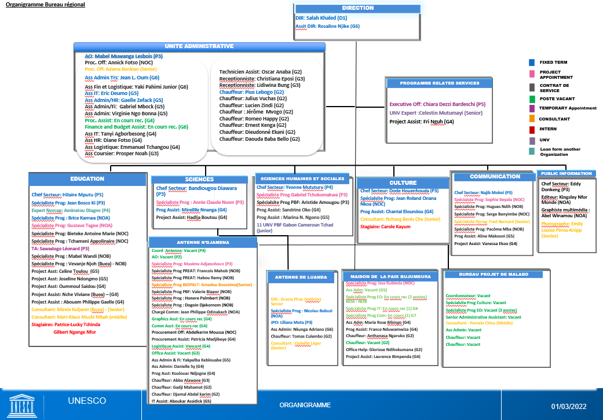

*Performance assessments for the past biennium*

* The performance assessment of the Head of Office was completed for the past biennium. The audit will review completion of performance assessment for the Office’s personnel during field work.
* The audit focal points

**Accountability framework and delegation of authority**

* *Framework*

* *Bank signatory rights from BFM/TRS*

*Segregation of duties risks*

Review of data shows adequate segregation of duties in the certifying and approving role for the creation of contracts in DUO-CMT (SAP). A sample of procurement contracts will be tested during fieldwork to ensure adequate segregation of duties for payment.

**Ethical conduct**

* The Ethics Office undertook a mission (

***Corruption Index.*** Transparency international Transparency international index ranks Costa Rica as 39/180 in the [Corruption Perception Index (CPI) 2020](https://www.transparency.org/en/cpi/2021/index/cri). The score for Costa Rica is 58 on a scale of 0 (very corrupt) to 100 (very clean). The country falls in Americas, a region that makes little progress in the fight against corruption.

The following areas where corrupt practices could influence the Offices activities will be closely reviewed to identify instances of corrupt / fraudulent actions:

* Contracting of goods and services
* Selection and remuneration of service contractors

|  |
| --- |
| **Risk Management** |

The Office assesses that its internal controls area globally under control.

**Results of the 2021 Control Self-Assessment**

**Medium and high residual risks from the risk register**

|  |
| --- |
| **Control Activities** |

**Payment Process in SAP**

Controls for the payment process include:

* Purchase orders: dual validation from certifying officer and director to create a purchase order and Service Entry Sheet by the contract owner which feeds automatically into a MIRO transaction validated by the Administrative unit and the outgoing posting by another. The dual control validation is embedded in the system for Purchase Orders payment through automated SOD for the creation of PO and MIRO (Good Receipt) transaction in SAP.

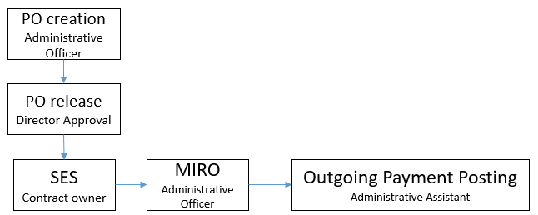

The important controls in this flow are the following:

* + **Segregation of duties between the PO creation and PO release**
  + **Verification of good receipts before doing the SES**
  + Segregation of duties between MIRO and outgoing payment posting but SOD in the previous flow should be sufficient
* Fund Reservation:



* The important controls in this flows is the **independent verification** of the invoice posting through supporting documentation for justification

To process the above payments in SAP, the Office uses payment request forms which are certified by the Administrative Officer and approved by the Head of Office.

**Local bank payments**



**Vendor management process**

* **SAP vendor creation**: perform a walkthrough
* **Local bank vendor creation**: For the local bank vendors, outside of SAP and not reconciled with SAP, the office pulls a PDF form from the bank website and input vendor bank information manually to be printed out as bank transfer form. This information is automatically stored in the bank form for future bank transfers. The form is signed by two bank signatories when there is bank transfer letter. They verify that the bank account details match the vendors’ check (equivalent to a bank official record), where the vendor’s name and bank account details appear.

**Key policies and documented procedures relevant to the audited area**

Most of the processes of the office are supposed to be carried out in line with the Admin Manual and the HR Manual.

**IT support and key systems:** Most of the Office is on Windows 10.

**Data Analysis**

* The Office RP budget for 2019-2020 amounts to US$977,945.

**Expenditures (1 Jan 2018 – 8 Feb 2022)**

The Office total expenditures between January 2018 to October 2020 totals US$5m.

|  |  |
| --- | --- |
| **ZPOLIST Budget Codes** | 4674670 |
| **FR from SJO** | 407554 |
| **Total** | 5082224 |

The Office drew 1883 contracts for a total amount of US$4,6 million between 2018 and October 2020 with a high number of Contracts for Services, small purchase orders and consultants.

|  |  |  |  |
| --- | --- | --- | --- |
| **Contract Type** | **Total Value** | **Number** | **% Value** |
| Contract for Services | 2 497 294,31 | 966 | 54% |
| Other – Non standard contracts | 1 379 639,25 | 26 | 30% |
| Consultants | 446 370,89 | 354 | 10% |
| IMPT - IPA | 147 709,67 | 8 | 3% |
| PORD (Small PO) | 88 599,58 | 473 | 2% |
| Utilities | 39 826,83 | 52 | 1% |
| Work orders | 4 540,40 | 4 | 0% |
| **Total** | **4 603 980,93** | **1 883** |  |

**List of funds used for commitments**

**Top vendors**

|  |  |
| --- | --- |
| **Vendor Name** | **Total** |
| ILEJI SA | 516 874,00 |
| SECURE SA | 382 195,57 |
| Centro de Negocios El Cedral CNEC | 312 339,28 |
| MICE CENTROAMERICANA S.A. | 214 464,72 |
| ICE INSTITUTO COSTARRICENSE DE | 178 515,96 |
| COORDINACION EDUCATIVA Y CULTURAL | 162 382,71 |
| TECNOLOGICA CONSULTORES REGIONALES, | 144 744,46 |
| INSTITUTO NICARAGUENSE DE CULTURA | 126 480,00 |
| AGENCIA DE VIAJES COLÓN S.A. | 120 252,91 |
| CNFL COMPANIA NACIONAL DE FUERZA Y | 119 290,20 |
| UNIVERSIDAD PARA LA PAZ | 118 840,00 |
| TIMES SQUARE TRAVE AGENCY SOCIEDAD | 109 000,00 |
| MINISTERIO DE HACIENDA Y CREDITO | 105 383,00 |
| Fundacion Comunidad | 98 200,00 |
| LIMPIEZA PROFUNDA LIMPROSA | 95 181,19 |
| Zúñiga Briceño Sandra Ivette | 84 975,66 |
| GALINDO OSORIO Marisela | 76 601,92 |
| FLACSO Costa Rica | 74 000,00 |
| Giraldo Rincón Marco Antonio | 69 628,00 |
| MUSEO NACIONAL DE COSTA RICA | 64 575,00 |
| Urban Developments Panama, S.A. | 59 728,00 |
| Bosch Pla Cristina | 57 148,75 |
| CYRANEK Günther Heinz | 57 093,00 |
| Condominio Horizontal Vertical | 55 566,44 |
| TURVI S.A. | 55 000,00 |
| Consejo Latinoamericano de Ciencias | 54 741,00 |
| RODRIGUEZ OLIVA Lazaro Israel | 54 149,00 |
| Mildred Corrales | 52 463,56 |
| Orellana Sergio | 50 231,08 |
| CLAUDIA CARDENAS | 49 500,00 |
| KINO GLAZ S.A DE C.V. | 48 000,00 |
| DORMAELS Mathieu Nicolas | 47 696,19 |
| CATIE | 46 475,00 |
| SERVICIOS NITIDOS PROFESIONALES SA | 46 268,02 |
| DEMETRIO Antolin Jacobo | 45 835,06 |
| SMM ENT LLC | 45 000,00 |

|  |
| --- |
| **Information and Communication** |

Explain the kind and sources of reports used in the sector, field office, programme, institute, etc. and indicate whether there are any expectations to report internally and externally.

**Internal reports used and systems for data extraction**

* Will determine whether the Office uses the P

**External reports and target audience, including any feedback from the audience**

**Social media reports for any positive or negative press about the programme/projects:**

* *Websites, journals, portals, newsletters, publications, etc*.

The office maintains a website in English with links to UNESCO news as well as publications relevant to the country.







**Results of donor inspections/spot checks/monitoring exercises and progress towards resolution of areas of improvement**

|  |
| --- |
| **Prior Reports by Assurance Providers** |

IOS has done several audits of the YAO Office in the past. For the purpose of the current assignment, IOS took into account the latest audit report completed in April 2019, attached hereunder. It is the most relevant one as well considering that it provides a good benchmark against which to measure the office as the current Director took up his functions in 2018.

The reports consists of 7 recommendations (4 High Priority and 3 Medium Priority). IOS notes that all recommendations were closed as it was concluded that agreed actions were implemented (see excel spreadsheet below with comments from the Client).

( )

IOS notes in its preliminary analysis of the current assignment that some recommendations (Recommendations 5 and 6) should not have been closed. Concern regarding procurement, contract management, accountabilities still prevail today. The audit fieldwork will further confirm this in due time.

**Preliminary Findings**

Interviews during the planning phase include:



|  |
| --- |
| **Audit Rationale, Scope and Objective** |

**Audit rationale**

The Office was last audited by IOS in 2018 and by the External Auditor in for the review of the consolidated financial statements.

**Audit objective**

The objective of the audit is to provide assurance on the effectiveness of internal controls, governance and risk management processes of the Yaounde Regional Office. Furthermore, review the efficiency, effectiveness and economy of the Office’s operations (including programme management, financial controls, procurement, travel, human resources management, security, IT, and general administration). These audit objectives will be assessed in the context of COVID-19 and how the office has responded to it. Due to travel restrictions as a result of COVID-19, the audit can only provide limited assurance as no physical inspections will be conducted. IOS/AUD is considering partnerships with local UN auditors to conduct physical inspections, if deemed necessary.

**Audit scope and period**

The audit will cover the Programme activities from 1 January 2019 to 30 October 2020, the audit team may also review other periods if necessary. The audit is planned as a full scope exercise, with a limited assurance due to the inability to physically travel to Kathmandu, Nepal during the COVID-19 global pandemic. The audit will cover the following areas:

* Overall governance of the Office (including objective setting, planning, and risk management)
* Programme
* Financial control
* Contracting and procurement
* Travel
* Human resources
* General administration

**Audit methodology**

The audit will be performed in accordance with the *International Standards for the Professional Practice of Internal Auditing* and OS audit manual.

The audit will assess the functioning of internal controls within the defined scope in order to identify major risks to the achievement of the Kathmandu Office objectives. Action plans will be agreed to strengthen risk management and controls, and to improve operations where warranted.

The audit will be based on surveys, interviews, data analysis, documentation review, etc. The audit team will select the sampling techniques such as judgemental, statistical, representative, etc. to ensure the sampling approach remains relevant to the test objectives.

**Key milestones**

IOS will conduct the audit of the Office per these timelines:

| **Milestone** | **Planned date** |
| --- | --- |
| Notification letter | 14 February 2022 |
| End of planning | 27 November 2020 |
| End of fieldwork | 23 December 2020 |
| Draft report | 22 January 2020 |
| Final report | Within two weeks of receiving comments |

**Audit resources**

The budgeted days for this assignment are 80 days as follows:

|  |  |  |  |  |  |
| --- | --- | --- | --- | --- | --- |
| **Activity/ Persons-days** | **Planning** | **Fieldwork** | **Draft report** | **Finalization** | **Total** |
| Head of Audit (Soriano) | 1 | 0 | 1 | 1 | 3 |
| Principal Auditor (Thanassoulias) | 15 | 15 | 10 | 2 | 42 |
| Associate Auditor (Tumurbaatar) | 9 | 20 | 5 | 1 | 35 |
| Total | 20 | 40 | 16 | 4 | 80 |

1. https://fr.unesco.org/fieldoffice/yaounde